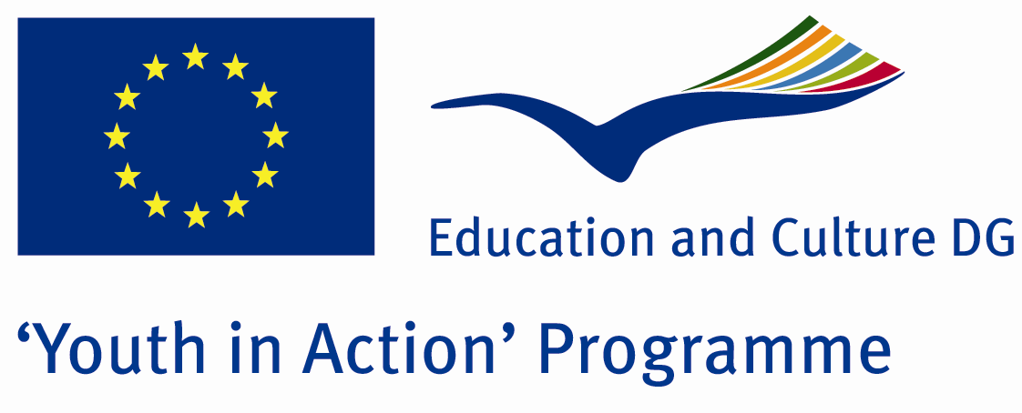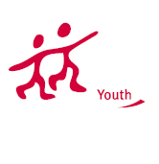

The Importance of Woman in The World



ACTION 4.3 – TRAINING AND NETWORKING

01-07th July, 2012

Kırklareli, TURKEY

ACTION 4.3 – TRAINING AND NETWORKING
01-07th July, 2012
Kırklareli, TURKEY

Please contact directly to;
tychestatuegroup@gmail.com
Project Summary;
The theme of our project work in the world of women's life and social life difficulties. Women in our project and business life, social life is limited, we can create new opportunities, so we decided to have the potential to make city İzmit.
Our project objectives compete with her business life with stress, improve the quality of the relationship between child and his wife, to prevent violence against women, social life, gain new skills and emphasize the importance of women's place in the world the second plan, considering the severity of women and discrimination of women in the world why we want to draw attention.
With this project we find solutions to the problems of women in the world to find practical solutions to improve the quality of social life we want to gain new perspectives.How can we improve women's social and business life in the world in the project and will try to find answer to the question we will talk lived the life of the woman in the world of business and social challenges with our partners.We will brainstorm with our partners around the world will try to find solutions to the problems of women.
Increase awareness of our thought that the slogan of a better life for women.Draw the attention of everyone in this topic everyone can share their thoughts on this issue.

Project Title; The Importance of woman in The World

Date and Venue ; 01-07th July, 2012 Kırklareli, Turkey .

Target Group ; Municipalities, City Councils and Non-Governmental organizations,
youth groups,culture and art groups,e.t.c

Participants ; 5 people from each country (over 18 -25 ). Totally 8 countries.

Conditions ; Accommodation, board and programme costs will be financed through European Commission Youth in Action Programme (Action 4.3). Travel costs will be reimbursed in 70% (APEX Tarrifs). Organizations from all 27 EU member countries plus Liechtenstein , Norway and Iceland are eligible to take part.

Working language: English

Organizer; Tychestatue Group

How to apply: If you are interested, please send your Part III forms to
by e-mail please (in word file). Scan Part3 format is enough for application.(Fulfilled Part III which you can find in the attachment, of course signed and stamped) ..

If you have any questions you may contact with:
tychestatuegroup@gmail.com

Deadline: 10th October 2011

